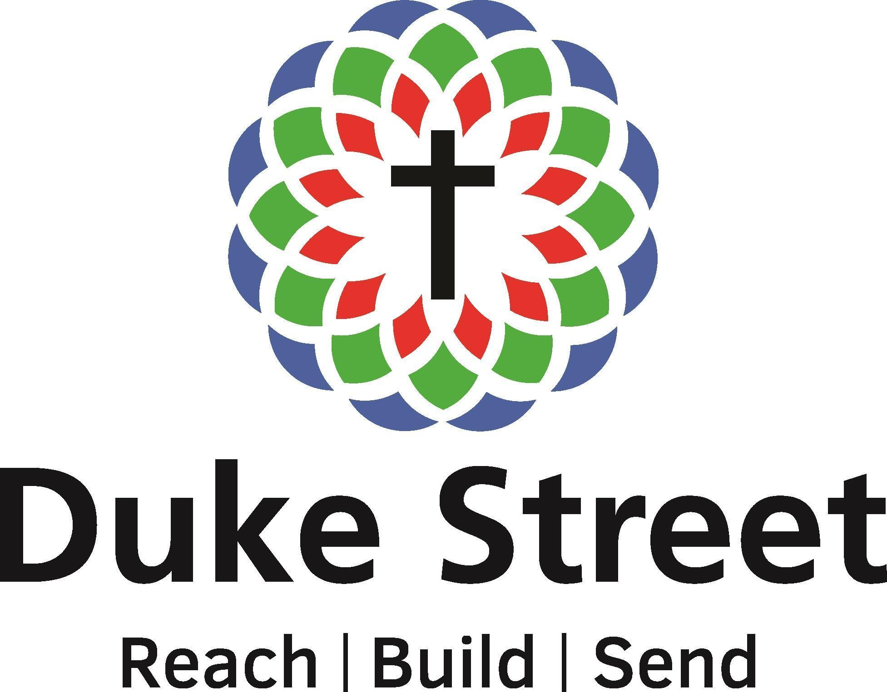
Duke Street Church
Children's, Youth and Families’ Worker
Application Form

Personal Information

Name :

Address :

Email :

Telephone :

Current occupation :

Employer’s name :

Church you attend :

Christian Experience

Please describe how and when you became a Christian.

Please confirm whether you agree with the Duke Street Church Statement of Faith and Doctrinal Distinctives. If not, please explain any areas of difference.

Please provide details of your previous and present involvement in Christian service, and in particular, your leadership experience.

Why do you want to be the Duke Street Church Children's, Youth and Families’ Worker?

Why are you thinking of leaving your current employment?

Why do you consider yourself suitable for this job (considering the personal qualities and experience we are seeking)?

What experience do you have of the following areas, particularly among children, youth and families?
- Children Ministry
- Youth Ministry
- Ministering to families
- Helping young people to integrate into church life and to access discipleship
- Leadership and volunteer development
- Outreach amongst young people, including schools’ work

In which areas would you hope to grow, or need support?

Is there anything else you’d like to add or consider we should be aware of?

Qualifications and Experience

Are you permitted legally to work in the UK? If yes, please provide details.

Academic qualifications.

Details of any relevant employment experience – and explain its significance

Please give details of any theological study undertaken.

Safeguarding

Disclosure Check: please confirm that you understand and agree to a DBS check should we wish to appoint you to the post.

Have you ever been convicted of or charged with a criminal offence or been bound over to keep the peace that has not been filtered in accordance with the DBS filtering rules?
Note: spent convictions do not need to be declared.
(see http://hub.unlock.org.uk/knowledgebase/spent-now-brief-guide-changes-roa/ for more information)

If yes, please provide details; we will need to discuss this with you.

Have you ever been involved in court proceedings or investigated by a church body about Safeguarding Concerns?

If yes, please give details.

References

Please provide the names and contact details of two referees (including your current pastor)
 | Referee 1 | Referee 2
Name
Church/Company
(if relevant)
Relationship
Email
Telephone

Declaration

I consent to a DBS check if appointed to the position for which I have applied. I am aware that details of pending prosecutions, previous convictions, cautions or bindovers against me will be disclosed along with any other relevant information which may be known to the police.

I confirm that the information given above is accurate and correct.

I understand that the appointment, if offered, will be subject to the information here being accurate and complete, references and any enhanced DBS being acceptable to the appointing officer and me being able to prove my right to work in the UK.

I agree to inform the Duke Street Church Trustees if I am convicted of an offence after I take up any post within Duke Street Church. I understand that failure to do so may lead to the immediate suspension of my work.

I agree to inform the Duke Street Church Trustees if I become the subject of a police and/or social services/social work department investigation. I understand that failure to do so may lead to the immediate suspension of my work and/or the termination of this work.

I understand that the information I provide will be used only for this recruitment process and handled in accordance with data protection legislation. I consent to Duke Street Church processing my personal data for this purpose.

By submitting this application, I confirm that I have read and agree to the above statements.

Name :

Signed : Date :

